KHALID HUSSAIN MOHAMMADANI
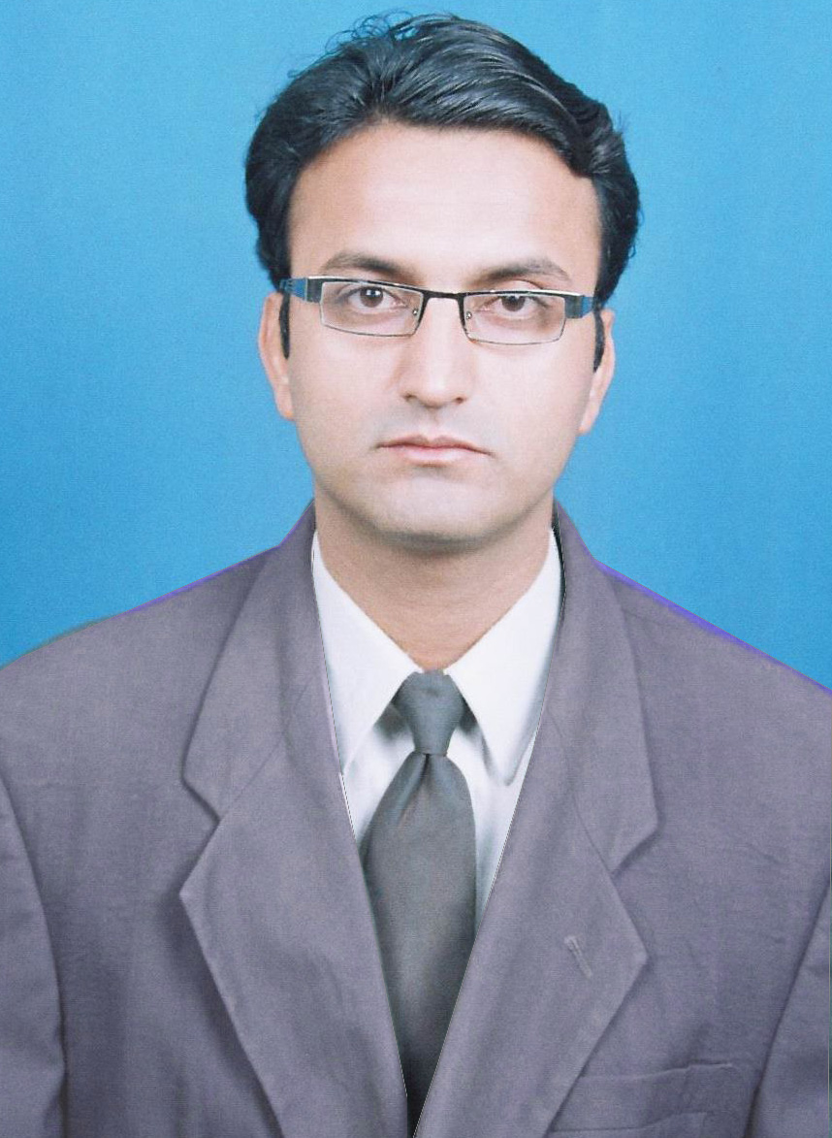
Address:
C-98, SUECHS, Jamshoro, Pakistan
Cell# +92 300 3798161
Email-khalid.mohammadani@gmail.com

OBJECTIVES:
- To obtain a challenging and rewarding position in public or private sectors where I can utilize best of my knowledge and abilities acquired during graduation coupled with devotion and drive for carrier growth.

EXPERIENCE:
- Present work:
  - 20 months worked as the Teaching Assistant, Institute of Information and Communication Technology, University of Sindh, Jamshoro, Pakistan.

- Web Developing training using PHP, MySql, Html, and JavaScript, Hidaya Trust, Jamshoro.
- Telecommunication Engineering Internship, 1st Feb 2009 to 4th April 2009,in field of Transmission Media i.e. NEC Passolink and SAF DRS Links, Alarm Management System, Power plant of BTSs and NMS WLL BSC (ZTE), PTCL, Faisalabad .

- Telecommunication Engineering Internship, (30-days) July 2008, WLL OMC, BSS based on CDMA2000 1X (Hawaii), PTCL, site area Hyderabad.
- Hardware Technician at Hi-Tech Computers sale and service Kandhkot.

EDUCATION:
- Present
  - Enrolled in M.Phil (Computer Science ),Isra university, Hyderabad, Pakistan
- BS (Telecommunication) (2005-2008) University of Sindh, Jamshoro, Pakistan Graduated with a GPA of 2.94 on a 4.0 scale.
- H.S.C-II (Pre Engineering) (2001-2003) B.I.S.E, Larkana
- Matriculation (Science) (2001) B.I.S.E, Larkana
- IT Trainings/Certifications
- Microsoft Certified System Engineer (MCSE 70-270, 70-290,70-291),
IBA Sukkur.
- Computer course (SC), Hi-Tech Institute of science and computer technology Kandhkot.

PROJECTS:
- Final Year Project
  - Implementation of VOIP based network at IICT, university of Sindh.

  - Description: Project focused on SIP based network architecture that integrates SIP clients, enabled SIP server which is open source PBX voice communication system based on Linux-OS that provides multimedia services such as voice/video/text over the IP network.
  - Tools used:. VM-workstation Software, Trixbox / Elastix /Asterisk Soft IP-PBX and X-lite Soft phone.

- PHP Projects
  - Online testing system
  - Online school management system
  - Online domicile system
  - Online reservation system
  - One assignment management system
  - Online Fir Verification
  - Online Load Management System for save web’s space

- PHP Projects Links
  - http://fast.netau.net
  - http://fast.netau.net/DomicileSystem/
  - http://fast.netau.net/test/
  - http://soofi.host22.com/

PROFESSIONAL SKILLS:
- Telecommunication skills
  - Field of Transmission(Microwave) Media NEC Passolink and SAF DRS Links
  - CDMA (CDMA Signal generation, Forward & Reverse Link Channels)
  - GSM and WLL (Architecture, Interfaces)
  - DDF E1’s Patching System
  - Alarm Management System and External Alarm System (EAS)
- Data Communication & Computer Networks
- Analog and digital communication Systems
- Database
  - MySQL (Queries & store procedures)

- Computer Language and Operating System
  - OS-Wind98/2k3/XP and DOS (Installation + Troubleshooting)
  - MS-Window2003 Server and client
  - MS-Office 2003/2007
  - C/C++

- Multimedia skills:
  - Adobe Photoshop, Ad- Dreamwear CS5
  - Ulead video editing tool.

- Web Engineering skills:
  - PHP-5.0
  - HTML, Javascript (Ajax)
  - CSS
- Additional software & Tools
  - Apache, XAMP,WAMP, PHPMyAdmin, Visual Web Developer 2008, MS.NET Framework 3.5, Web Page Maker, Php Maker.

ACTIVITIES:
- Perform Nimaz and Recitation of Holy Quran
- Internet browsing studying, listen to lectures
- Reading Telecom related books

REFERENCES:
- Ms. Arjumand Bano, Lecturer , IICT, University of Sindh.

